|  |  |  |  |  |  |
| --- | --- | --- | --- | --- | --- |
| Date | 7-Dec-22 | | | Tester Name | Richard Belanger |
| Environment | Penfax - Test | | | Login used | TEST2 |
| Operating System | Windows | Version: | Update: | | |
| Software Used | Edge | Version: | Update: | | |
| Select Software | Version: | Update: | | |
| Release version | 22.4.1 | | | | |
| Title | M28.06 Fields on the screens are left Justified | | | | |
| Test Type | Regression | | | | |
| Test Scenario | Fields on the screens are left Justified | | | | |
|  |  | | | | |
| Expected Results | The fields will be justified to the left | | | | |
| Pass/Fail | Pass | | | JIRA# | N/A |

Describe your steps with screenshots:

Navigation Bar is seen on left-side of screen

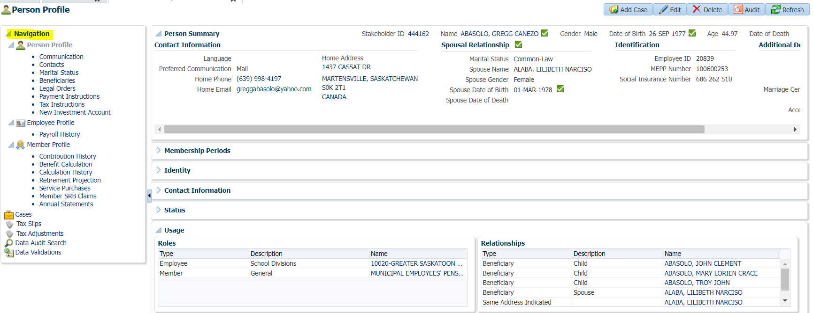

1. Person Profile Region

Descriptors are to the left of the related information- Correct

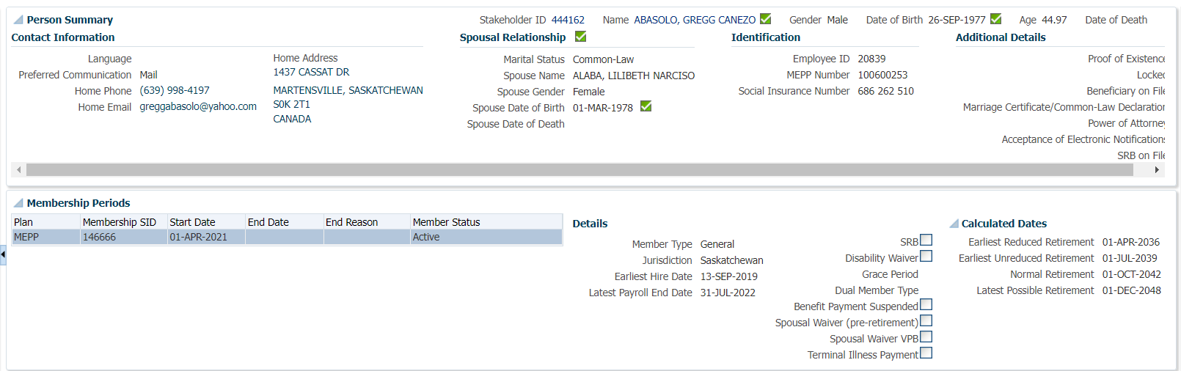

Remainder of Person Profile Region all left justified- Correct

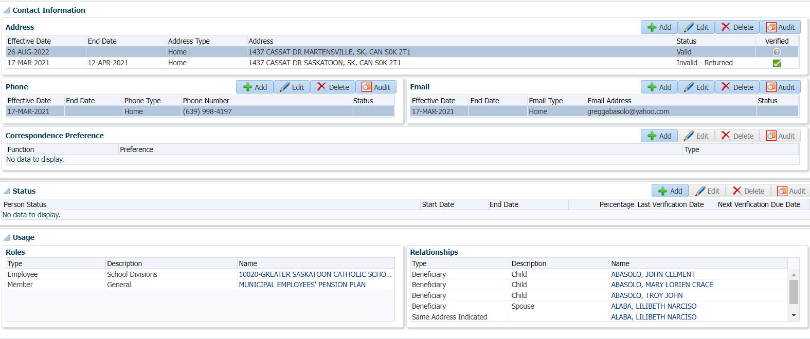

Examples within Person Profile

Beneficiaries, Descriptors are Left Justified – Correct

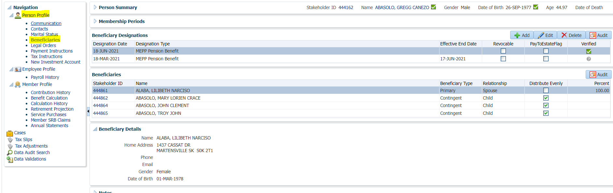

Tax Instructions, Descriptors are Left Justified – Correct

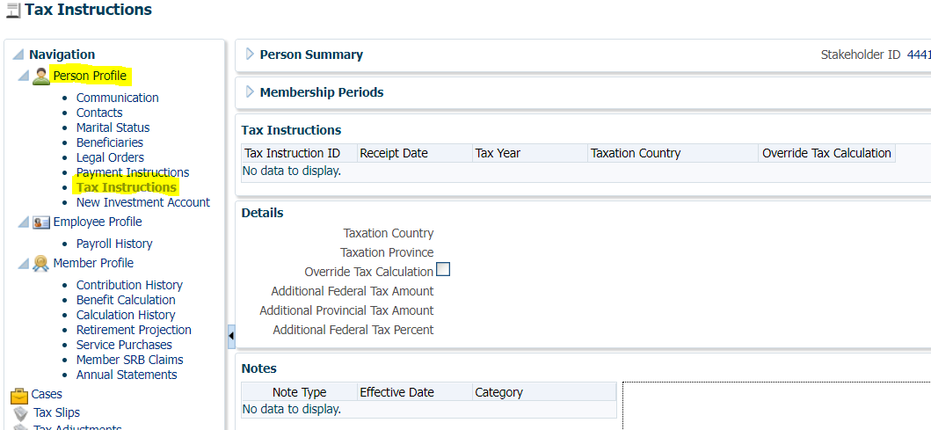

1. Employee Profile

Descriptors are to the left of the related information- Correct

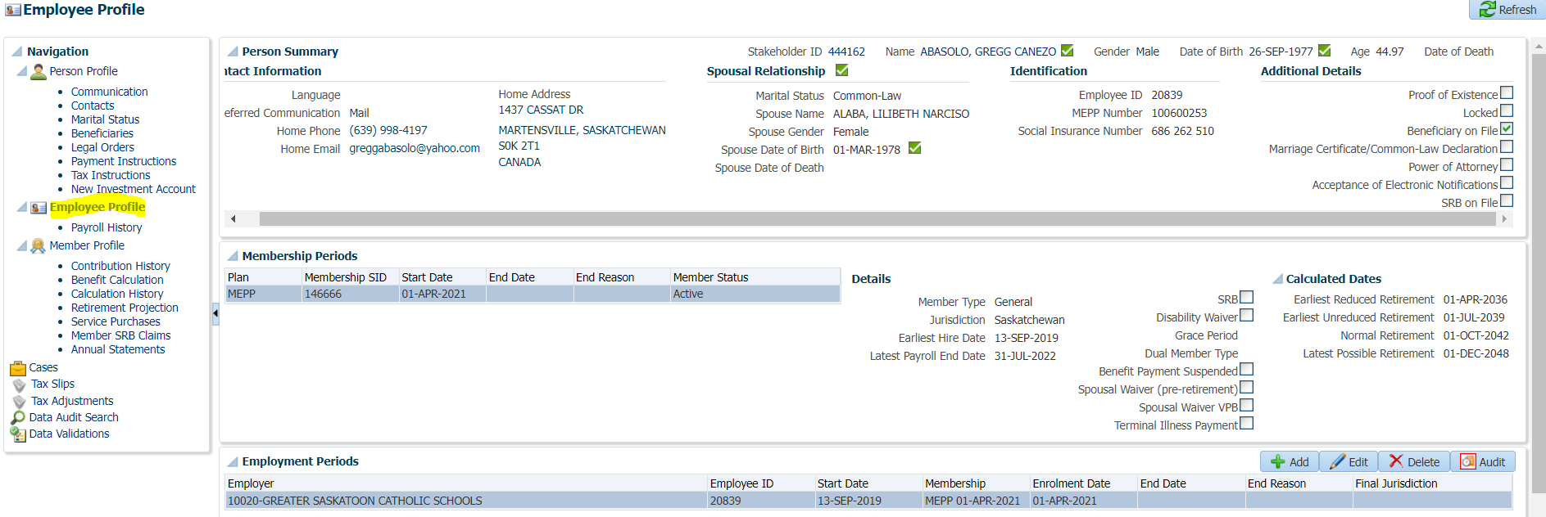

Remainder of Employee Profile Region all left justified- Correct

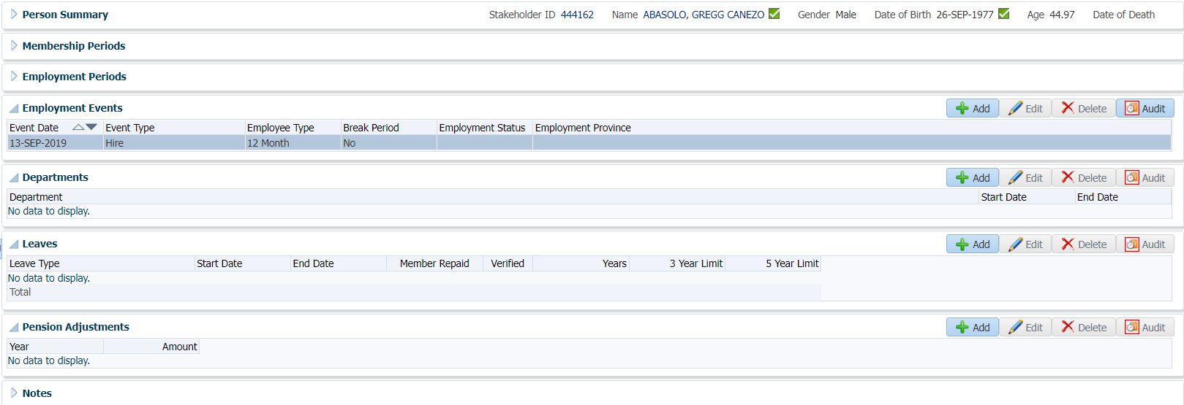

Payroll History, Descriptors are to the left of the related information- Correct

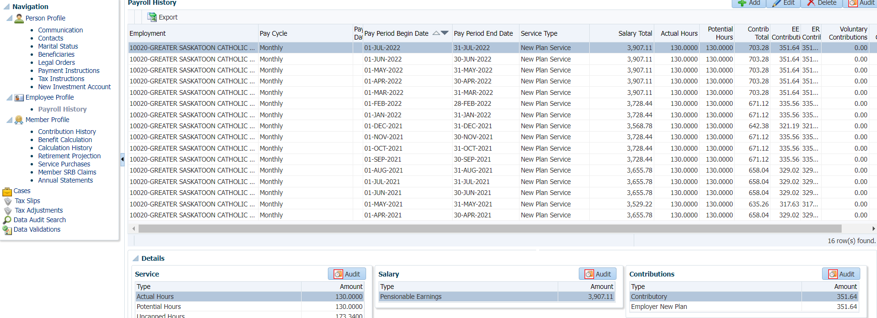

1. Member Profile

Descriptors are to the left of the related information- Correct

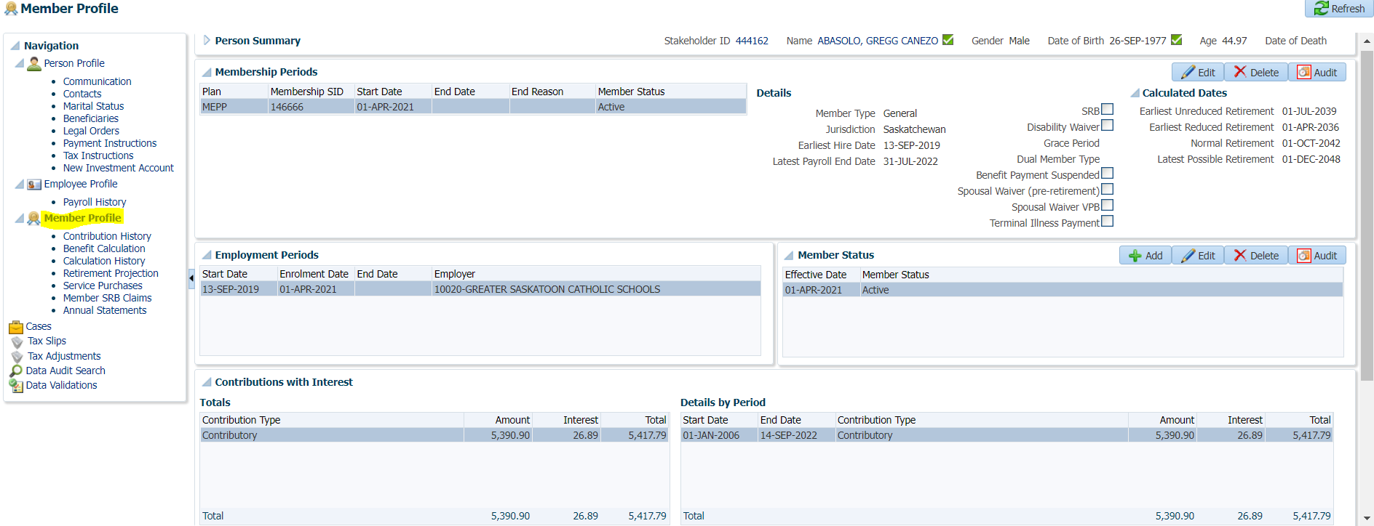

Remainder of Member Profile Region all left justified- Correct

